AI-AUGMENTED BACKEND DEVELOPMENT PROJECT
AI Blog Nest API
Team ID: SWTID-2026-8569
Date: 26 September 2026

1. Project Description
AI Blog Nest API is an AI-augmented backend web application designed to simplify blog content creation and management. The application provides user registration and login, JWT-based authentication, blog creation, AI-powered blog generation, and AI-powered content summarization through REST API endpoints. Users can register with their name, email and password, authenticate using their credentials, create blogs using a title, content and category, generate a blog from a topic and category, and submit content for summarization. The application combines conventional backend API development with AI capabilities to reduce manual effort and improve the efficiency of content creation.

2. Scenario

Paragraph 1 – Problem
Bloggers and content creators often spend considerable time researching topics, drafting articles, editing content and preparing summaries. When these activities are handled manually or through separate tools, the process becomes repetitive and time-consuming. Users also need secure authentication and a convenient way to create and manage blog content through an application.

Paragraph 2 – AI Solution
AI Blog Nest API addresses this need by combining authentication, blog management and AI-assisted content functions in one REST API. The API provides registration and login endpoints with token-based authentication, a protected blog creation endpoint, an AI blog-generation endpoint that accepts a topic and category, and an AI summarization endpoint that accepts content and returns a generated summary. The AI functions reduce the amount of manual writing and summarization required from the user.

Paragraph 3 – Impact
The solution is intended for bloggers, content creators and applications that need programmatic blog and AI content functionality. By centralizing these capabilities in an API, the system can make content workflows more convenient, reduce repetitive work and provide a reusable backend that can be integrated with a web or mobile interface.

3. System Requirements

Software Requirements
Requirement | Specification
Operating System | Windows 10/11, macOS or Linux
Node.js | v18 or above
npm | v9 or above
Backend Framework | Express.js / Node.js
Database | MongoDB Community Server or MongoDB Atlas
AI Service | AI API used by the project for blog generation and summarization
API Testing | Thunder Client / Postman
Development Environment | Visual Studio Code
Version Control | Git & GitHub, if used

Hardware Requirements
- Processor: Intel Core i5 (8th Gen+) / AMD Ryzen 5+ or equivalent
- RAM: Minimum 8 GB; 16 GB recommended
- Storage: Minimum 5 GB free space for the project and dependencies
- Internet connection: Required for external AI API communication
- Display: 1366 × 768 or above

4. Project Architecture

Technical Architecture
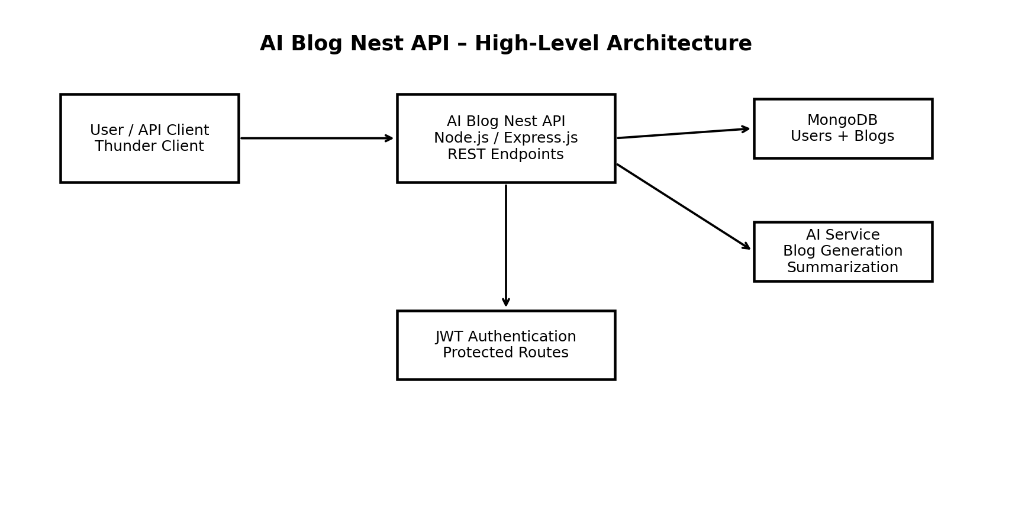

Backend Layer
- Node.js
- Express.js
- REST APIs
- JWT authentication

Database Layer
- MongoDB for application data such as users and blogs

AI Layer
- AI API integration for blog generation and content summarization
- Prompt/request construction and response handling

Security Layer
- JWT/Bearer token authentication
- Protected routes
- Input validation
Note: Semantic Search, MongoDB Atlas Vector Search, RAG and recommendation features are not evidenced by the supplied API testing screenshots; they are therefore not described as completed functionality in this document.

5. ER Diagram
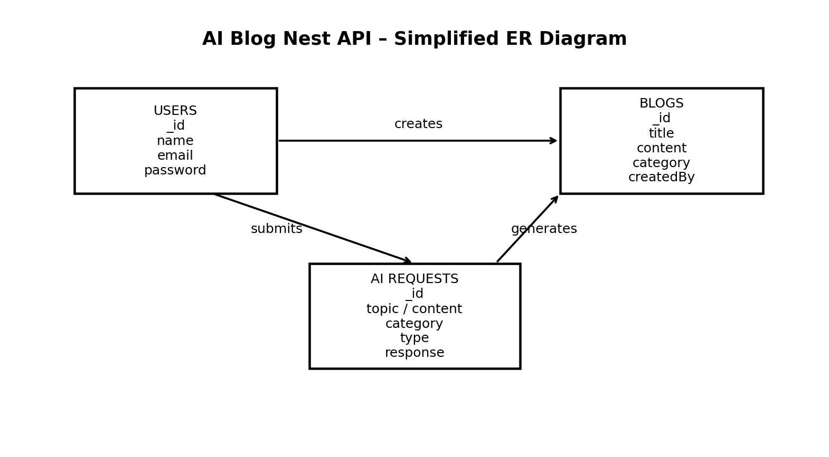

Collections / Data Entities
- Users: _id, name, email, password (stored securely), role where applicable.
- Blogs: _id, title, content, category, createdBy/user reference where implemented.
- AI Requests: request/input information and generated response where such records are stored by the implementation.

ER Diagram Explanation
A registered user can authenticate with the system and create blog content. Blog records contain the title, content and category supplied by the user. AI requests are used for generation or summarization and produce an AI response. The exact persistence of AI request records depends on the implementation.

6. Features

Core Backend Features
- User Registration
- User Login
- JWT/Bearer Authentication
- Protected API Requests
- Middleware / Request Validation
- Blog Creation
- REST API Endpoints

AI Features
- AI Blog / Content Generation
- Text Summarization
The supplied API evidence demonstrates successful blog generation and summarization requests. Other template-listed AI features such as semantic search, vector search, RAG, recommendations and document question answering are not evidenced in the supplied screenshots.

7. Roles and Responsibilities

User
- Register and log in
- Use the authentication token for protected operations
- Create blogs
- Generate blog content using AI
- Submit content for AI summarization

Administrator
Administrative functions are not evidenced in the supplied API testing material. Add administrator-specific permissions only if they are implemented in the project.

8. User Flow
1. User Registration
2. User Login
3. JWT/Bearer Authentication
4. Access protected API functionality
5. Create a Blog
6. Submit a topic and category for AI Blog Generation
7. Receive generated blog title and content
8. Submit content for AI Summarization
9. Receive the generated summary

9. MVC Pattern
The backend can be organized using the MVC (Model-View-Controller) pattern to separate data models, business logic and API routes.

Model Layer
- User model/schema
- Blog model/schema
- Database access and validation

Controller Layer
- Authentication logic
- Blog creation logic
- AI API integration
- Request/response handling

View / Route Layer
- REST API routes for registration, login, blogs and AI services

Advantages of MVC
- Separation of concerns
- Better maintainability
- Reusable components
- Easier testing
- Scalability of the codebase

10. API Endpoints Demonstrated
Method | Endpoint | Purpose | Evidence
POST | /api/auth/register | Register a new user | 201 Created – User registered successfully
POST | /api/auth/login | Authenticate user | 200 OK – JWT token returned
POST | /api/blogs | Create a blog with title, content and category | Request shown with Bearer authorization
POST | /api/ai/generate-blog | Generate a blog using topic and category | 201 Created – generated title/content returned
POST | /api/ai/summarize | Summarize supplied content | 200 OK – summary returned

11. Project Setup and Configuration

Suggested Project Structure
- server/
- server.js
- models/
- controllers/
- routes/
- middlewares/
- config/
- services/
- utils/

Backend Packages
Install the packages actually used by the implementation. The project template lists Express, Mongoose, CORS, dotenv, bcryptjs, jsonwebtoken, OpenAI, multer and nodemon as example dependencies; remove any package that is not used by the project.
Example:
npm install express mongoose cors dotenv bcryptjs jsonwebtoken
npm install openai
npm install multer
npm install nodemon --save-dev

12. Backend Development
- Authentication APIs
- JWT implementation
- Blog CRUD / creation APIs
- AI blog generation integration
- AI summarization integration
- Request validation and protected routes

AI API Integration – Documentation Required
- Purpose: generate blog content and summarize submitted content.
- Request structure: JSON input containing topic/category for generation, or content for summarization.
- Response structure: generated blog title/content or a summary.
- Cost considerations: depend on the AI service provider and model used.
- Security practices: keep API keys in environment variables and do not expose them in client-side code or documents.

13. Database Development
The template specifies MongoDB/Mongoose as the database technology. The demonstrated API requires persistent user and blog data. Configure the actual MongoDB connection string in the project environment rather than hard-coding credentials.
- Users collection / model
- Blogs collection / model
- Indexes appropriate to the implemented queries
- Sample user and blog documents

14. Project Execution

Step 1: Start the backend
cd server
npm install
npm start / nodemon server.js (use the command configured in package.json)

Step 2: Configure Environment Variables
Use a .env file and keep secrets out of source control. The exact variable names should match the project's code.
PORT=5000
MONGO_URI=<your MongoDB connection string>
JWT_SECRET=<your JWT secret>
OPENAI_API_KEY=<your AI provider key, if OpenAI is used>

Step 3: Backend URL
http://localhost:5000

15. API Testing Evidence
The following supplied Thunder Client screenshots demonstrate the implemented API functions.

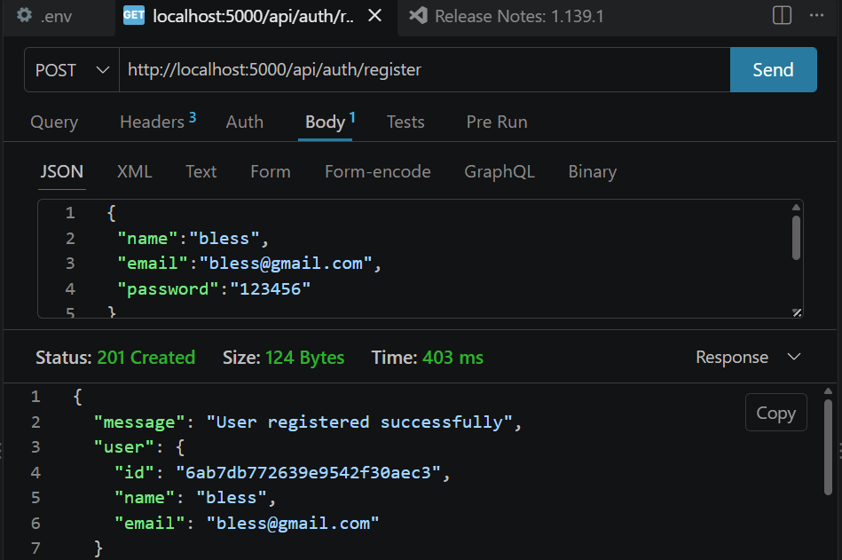
User Registration – 201 Created

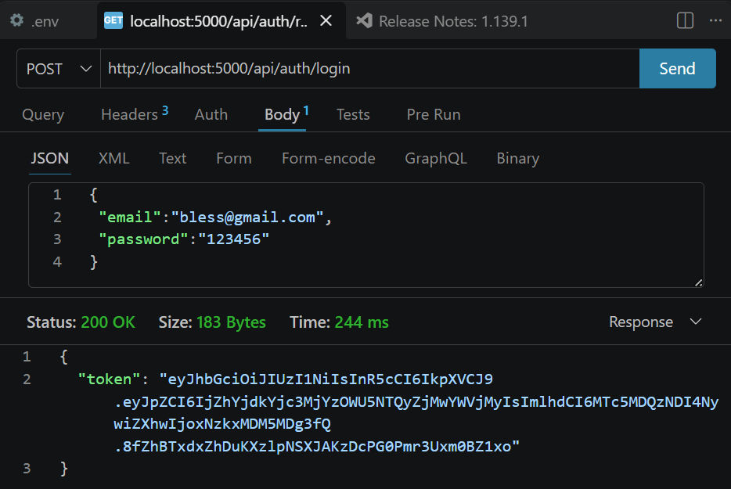
User Login – 200 OK and token returned

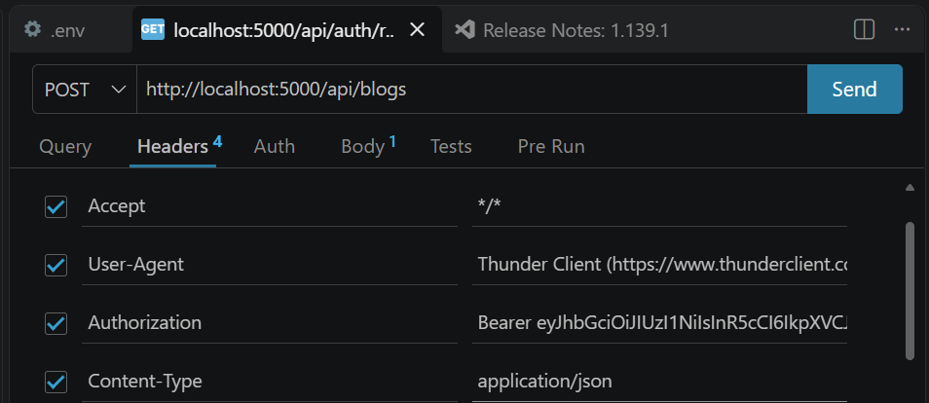
Create Blog request with Bearer authorization

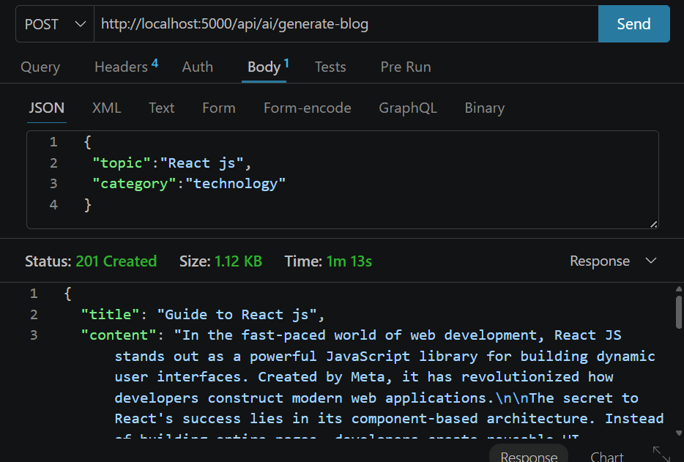
AI Blog Generation – 201 Created

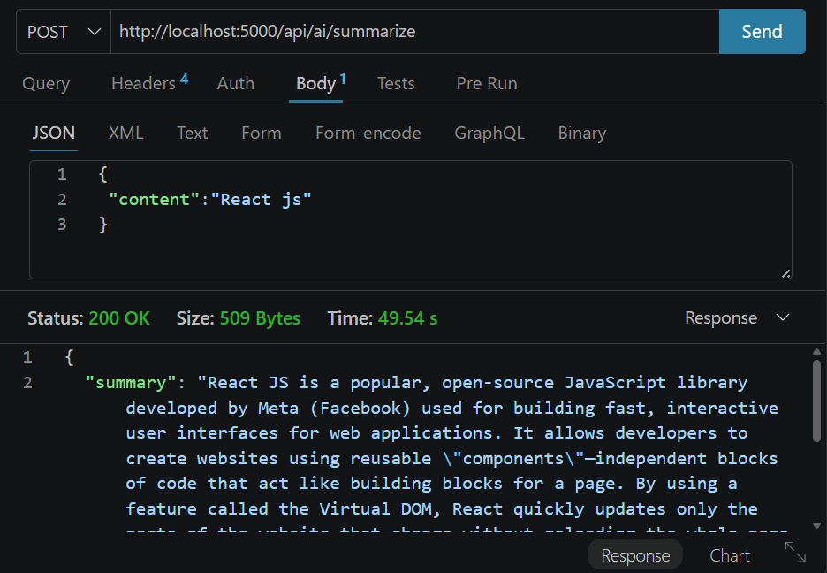
AI Summarization – 200 OK

16. Demo Video Link Project Video.mp4

17. Source Code Drive Code Files

18. Git Hub Link https://github.com/varshavelappan-lab/TN-NM-AI-AUGUMENTED-BACKEND-PROJECT.git

